Enhancing Academic Data Insights Through SQL Views and CTES
Create tables
- Create the Students table and insert values into it
- Create the Courses table and insert values into it
- Create the Instructors table and insert values into it
- Create the Enrolments table and insert the values into it
- Create a view named CourseSummary that shows the total number of students enrolled in each course
- CREATE TABLE Students (
- StudentID INTEGER PRIMARY KEY,
- FirstName TEXT NOT NULL,
- LastName TEXT NOT NULL,
- DOB TEXT NOT NULL,
- Major TEXT NOT NULL,
- GPA REAL NOT NULL
- );

- CREATE TABLE Courses (
- CourseID INTEGER PRIMARY KEY,
- CourseName TEXT NOT NULL,
- Department TEXT NOT NULL
- );

- CREATE TABLE Instructors (
- InstructorID INTEGER PRIMARY KEY,
- InstructorName TEXT NOT NULL,
- Department TEXT NOT NULL
- );

- CREATE TABLE Enrolments (
- EnrollmentID INTEGER PRIMARY KEY,
- StudentID INTEGER NOT NULL,
- CourseID INTEGER NOT NULL,
- Semester TEXT NOT NULL,
- Grade TEXT NOT NULL,
- FOREIGN KEY (StudentID) REFERENCES Students(StudentID),
- FOREIGN KEY (CourseID) REFERENCES Courses(CourseID)
- );

CREATE VIEW CourseSummary AS
SELECT c.CourseID,
c.CourseName,
COUNT(e.EnrollmentID) AS TotalEnrollment
FROM Courses AS c
LEFT JOIN Enrolments AS e
ON e.CourseID = c.CourseID
GROUP BY c.CourseID, c.CourseName;

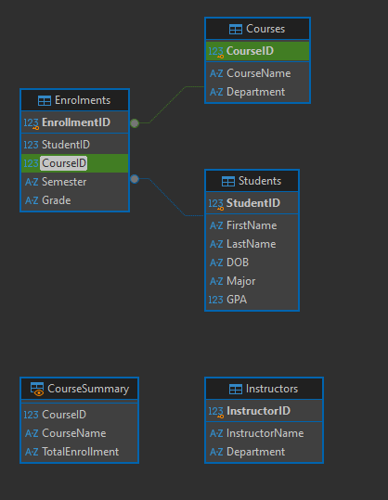

Create a view InstructorSchedule
- Create a view InstructorSchedule that lists each instructor's courses and department

CREATE VIEW InstructorSchedule AS
SELECT i.InstructorID,
i.InstructorName,
c.CourseID,
c.CourseName,
i.Department
FROM Instructors AS i
JOIN Courses AS c
ON i.Department = c.Department;

Modify CourseSummary
- Modify the CourseSummary view to list the distinct semesters each course was offered, along with the total student enrolment
- CREATE VIEW CourseSummary AS
- SELECT c.CourseID,
- c.CourseName,
- GROUP_CONCAT(DISTINCT e.Semester) AS SemestersOffered,
- COUNT(e.EnrollmentID) AS TotalEnrollment
- FROM Courses AS c
- LEFT JOIN Enrolments AS e
- ON e.CourseID = c.CourseID
- GROUP BY c.CourseID, c.CourseName;

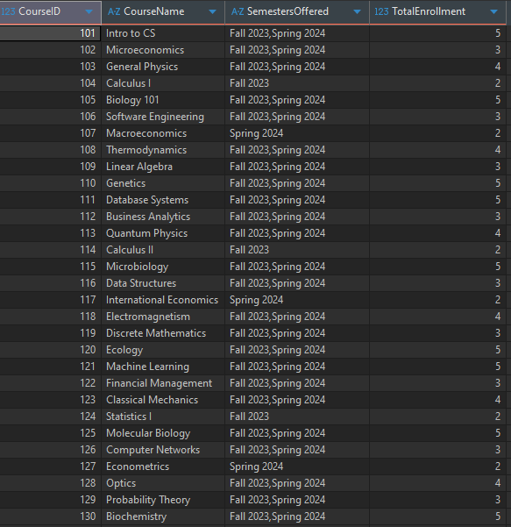

Update InstructorSchedule
CREATE VIEW InstructorSchedule AS
SELECT DISTINCT
i.InstructorID,
i.InstructorName,
c.CourseID,
c.CourseName,
i.Department,
e.Semester
FROM Instructors AS i
JOIN Courses AS c
ON c.Department = i.Department
JOIN Enrolments AS e
ON e.CourseID = c.CourseID
WHERE e.Semester = 'Spring 2024';

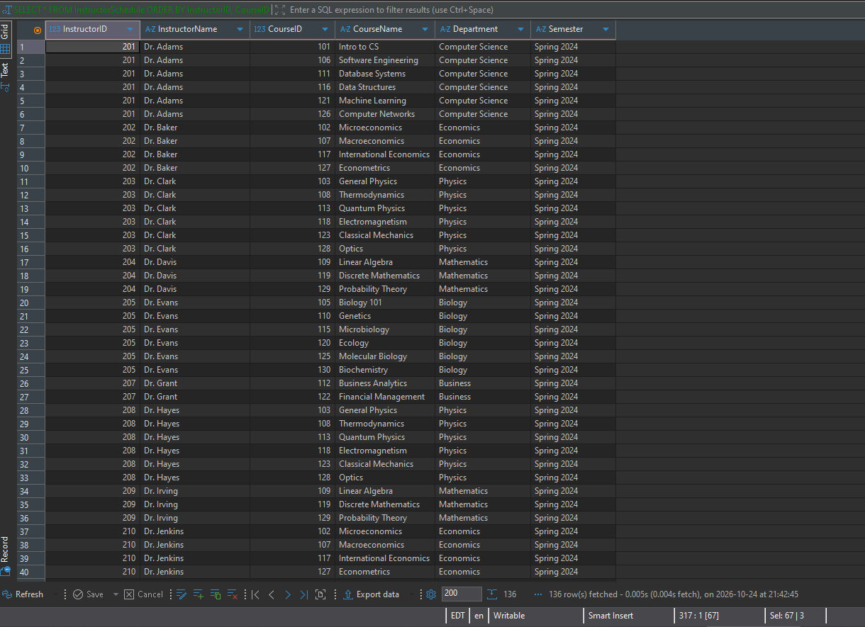

Create a view EligibleGraduates that lists students eligible for graduation whose GPA is greater than or equal to 3.7
CREATE VIEW EligibleGraduates AS
SELECT StudentID, FirstName, LastName, GPA
FROM Students
WHERE GPA >= 3.7;

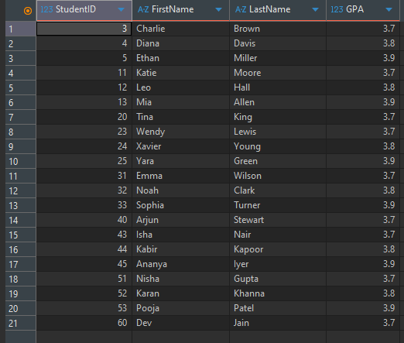

Alter EligibleGraduates to include students' GPAs

DROP VIEW IF EXISTS EligibleGraduates;
CREATE VIEW EligibleGraduates AS
SELECT StudentID, FirstName, LastName, GPA
FROM Students
WHERE GPA >= 3.7;

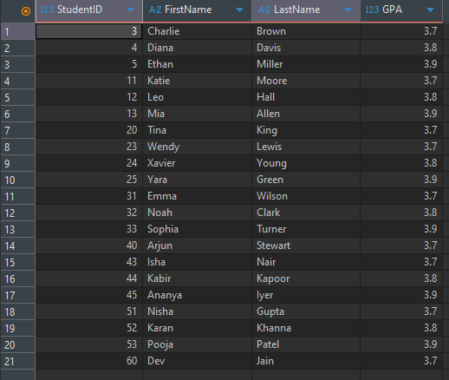

Rename Course Summary to Course Enrolment Summary
CREATE VIEW CourseEnrolmentSummary AS
SELECT c.CourseID,
c.CourseName,
GROUP_CONCAT(DISTINCT e.Semester) AS SemestersOffered,
COUNT(e.EnrollmentID) AS TotalEnrollment
FROM Courses AS c
LEFT JOIN Enrolments AS e
ON e.CourseID = c.CourseID
GROUP BY c.CourseID, c.CourseName;

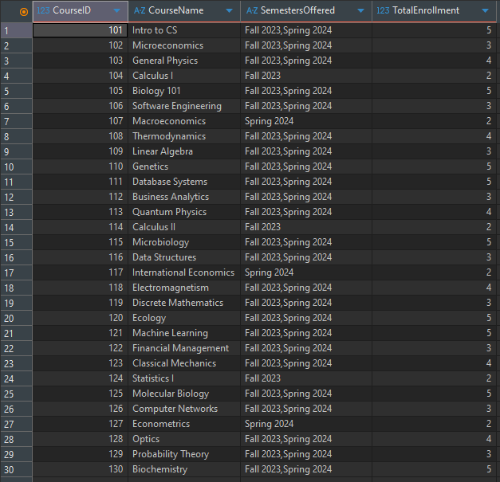

Create a CTE named SemesterCourses to list all courses offered in the current semester
WITH SemesterCourses AS (
SELECT DISTINCT
c.CourseID,
c.CourseName,
c.Department
FROM Courses AS c
JOIN Enrolments AS e
ON e.CourseID = c.CourseID
WHERE e.Semester = 'Spring 2024'
)
SELECT *
FROM SemesterCourses
ORDER BY CourseID;



